DEGREE OF Bachelor oF ARTS

Honour School of Oriental Studies

Korean

(COLLECTION)

Korean (as 2nd Language): Korean TEXTS

HILARY TERM 2023

Friday, 13th January

XX.XX - XX.XX (Time)

Please do not turn over until told that you may do so

1
Part 1. Translate the Korean passage into colloquial English and answer ALL questions.

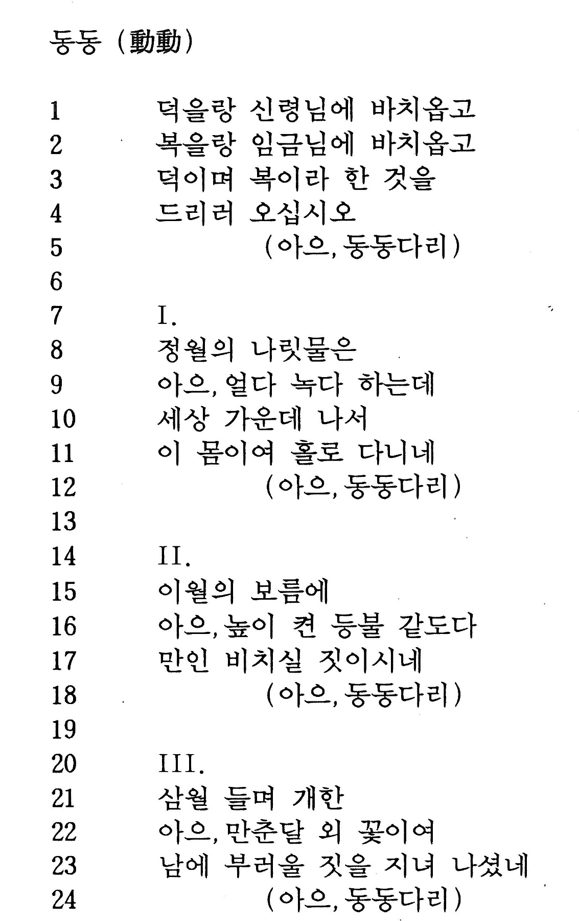

A14110W1 2

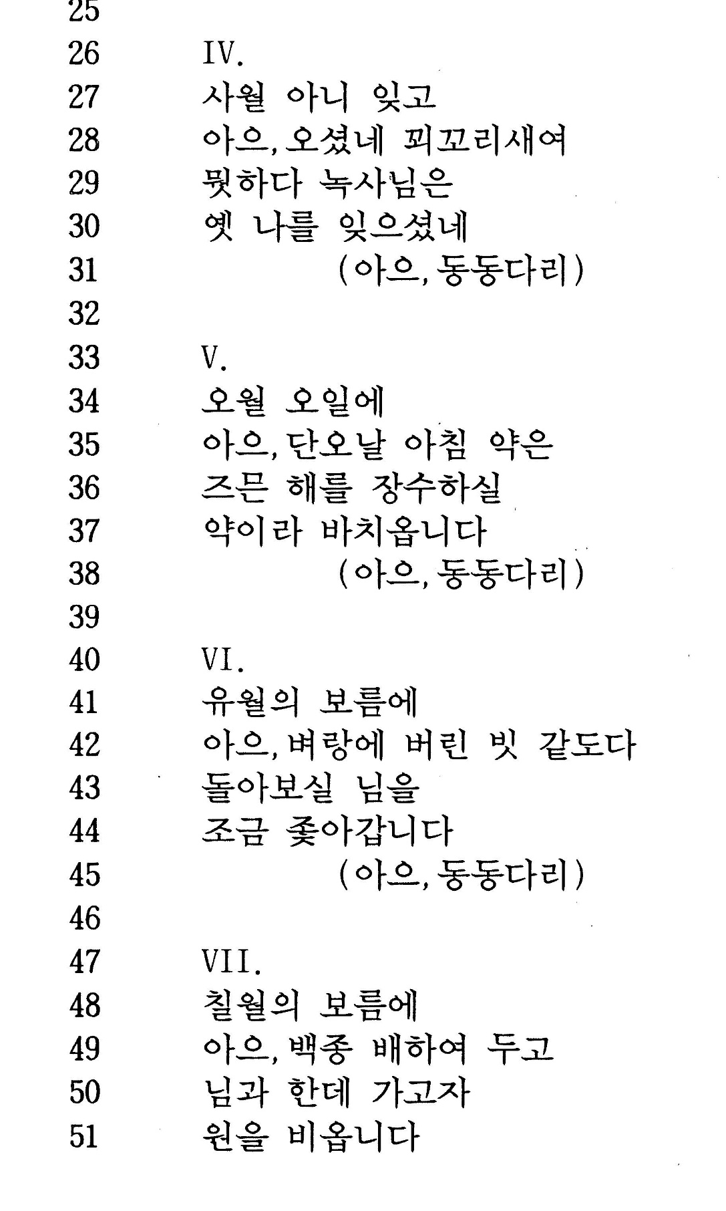

A14110W1 3 TURN OVER
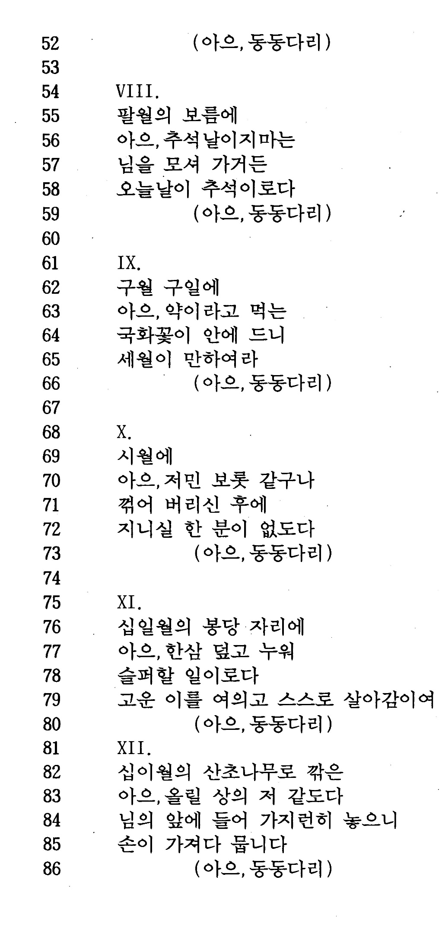

1. Do we know the author? Where do we find this song? What is the date and dynasty of the source and why is the date relevant?
2. What does the story say about society and social relations?

A14110W1 4 LAST PAGE

